



**Scaling Digital Twin Experiences 303  
Configurations with the Experience Server CDS**

**Copyright © 2020 PTC Inc. and/or Its Subsidiary Companies. All Rights Reserved.**

User and training guides and related documentation from PTC Inc. and its subsidiary companies (collectively "PTC") are subject to the copyright laws of the United States and other countries and are provided under a license agreement that restricts copying, disclosure, and use of such documentation. PTC hereby grants to the licensed software user the right to make copies in printed form of this documentation if provided on software media, but only for internal/personal use and in accordance with the license agreement under which the applicable software is licensed. Any copy made shall include the PTC copyright notice and any other proprietary notice provided by PTC. Training materials may not be copied without the express written consent of PTC. This documentation may not be disclosed, transferred, modified, or reduced to any form, including electronic media, or transmitted or made publicly available by any means without the prior written consent of PTC and no authorization is granted to make copies for such purposes. Information described herein is furnished for general information only, is subject to change without notice, and should not be construed as a warranty or commitment by PTC. PTC assumes no responsibility or liability for any errors or inaccuracies that may appear in this document.

The software described in this document is provided under written license agreement, contains valuable trade secrets and proprietary information, and is protected by the copyright laws of the United States and other countries. It may not be copied or distributed in any form or medium, disclosed to third parties, or used in any manner not provided for in the software licenses agreement except with written prior approval from PTC.

UNAUTHORIZED USE OF SOFTWARE OR ITS DOCUMENTATION CAN RESULT IN CIVIL DAMAGES AND CRIMINAL PROSECUTION.

PTC regards software piracy as the crime it is, and we view offenders accordingly. We do not tolerate the piracy of PTC software products, and we pursue (both civilly and criminally) those who do so using all legal means available, including public and private surveillance resources. As part of these efforts, PTC uses data monitoring and scouring technologies to obtain and transmit data on users of illegal copies of our software. This data collection is not performed on users of legally licensed software from PTC and its authorized distributors. If you are using an illegal copy of our software and do not consent to the collection and transmission of such data (including to the United States), cease using the illegal version, and contact PTC to obtain a legally licensed copy.

**Important Copyright, Trademark, Patent, and Licensing Information:** See the About Box, or copyright notice, of your PTC software.

**UNITED STATES GOVERNMENT RIGHTS**

PTC software products and software documentation are “commercial items” as that term is defined at 48 C.F.

1. 2.101. Pursuant to Federal Acquisition Regulation (FAR) 12.212 (a)-(b) (Computer Software) (MAY 2014) for civilian agencies or the Defense Federal Acquisition Regulation Supplement (DFARS) at 227.7202-1(a) (Policy) and 227.7202-3 (a) (Rights in commercial computer software or commercial computer software documentation) (FEB 2014) for the Department of Defense, PTC software products and software documentation are provided to the U.S. Government under the PTC commercial license agreement. Use, duplication or disclosure by the U.S. Government is subject solely to the terms and conditions set forth in the applicable PTC software license agreement.

PTC Inc., 121 Seaport Blvd, Boston, MA 02210 USA

**Intro**

In addition to being able to use the IRS and Thingworx for configuring your AR experience, you can use a feature of the Experience Service called the Content Delivery Service CDS). The Content Delivery Service is a facility designed for holding ‘static’ content, data that doesn’t change too often. The 3d representations of a product – the pvz files – and any 3d model target, these will typically not change once a product is released, so these are good candidates for content that could be managed within the CDS. In this example, we will adapt our previous example and we will place the ‘static’ content such as models into the CDS, and we will continue to use Thingworx for the dynamic content e.g. the battery charge information from the IOT system.

**301.1 Creating the content package**

*TODO : Describe that is required in the zip file*

**301.2 Uploading content to the CDS**

*TODO : Describe that is required*

**301.3 Set Up Vuforia Studio**

Once you have created Things inside ThingWorx, you will need to connect them to your Vuforia Studio experience.

1. Open the ScalingDigitalTwinExperiences202experience in Vuforia Studio. The same experience is used since the template is already mapped to the IRS, but you could redo the mapping process for another experience if you wanted to as well.

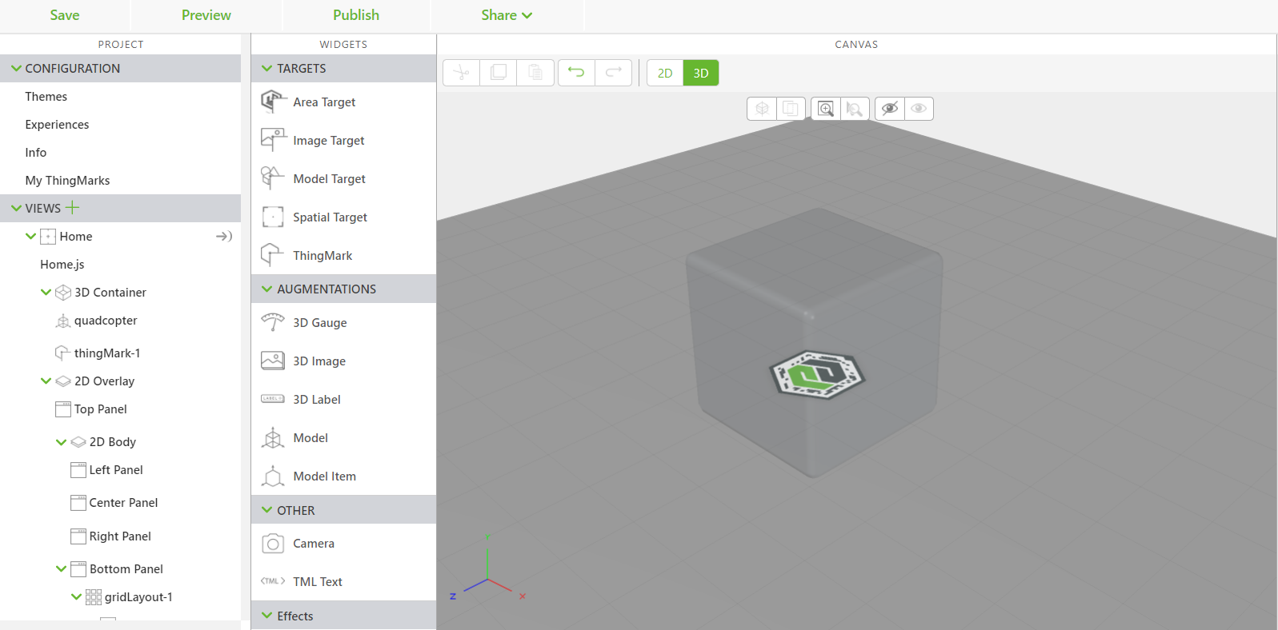

1. Drag a 3D Gauge widget onto the canvas. This will be used to display the batteryCharge property of the Quadcopter Thing.
   1. Drag the gauge so it is above where the quadcopter model widget is located.
   2. Change the **Resource** property of the 3D Gauge widget to be the stock vu_battery.svg image that is included in Studio. This will create a battery life icon on the gauge.
   3. Make sure that the **Billboard** property is selected for the widget so the gauge is always facing towards you in the experience.

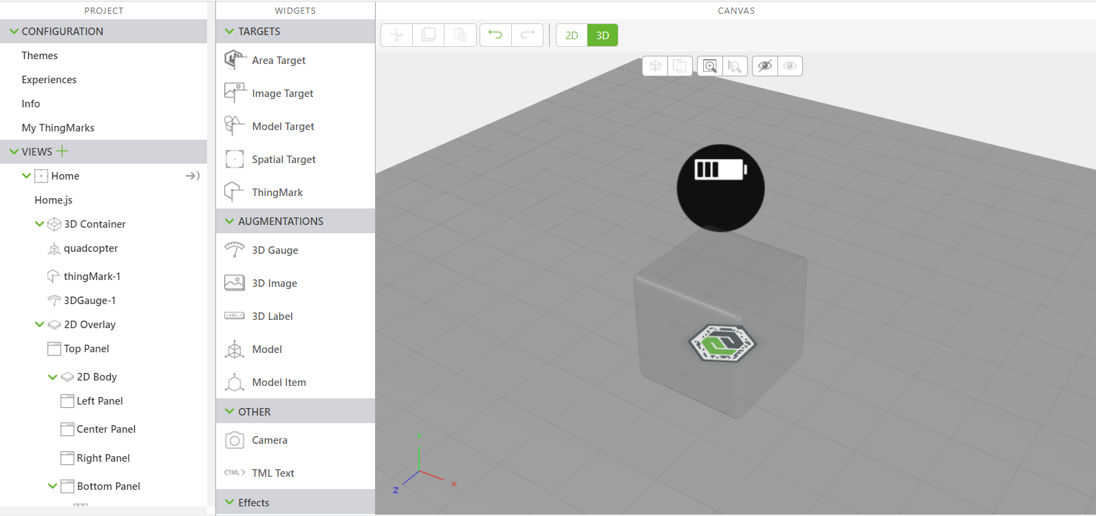

1. Open the **Data** pane on the right side of the screen.

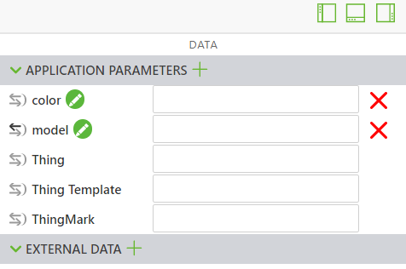

1. Click the green **+** next to **External Data**. The **Add External Data** window opens.
2. In the **Entities** search bar, type quadcopter. You should see your three numbered Quadcopter Things and the Quadcopter Template Thing Template.

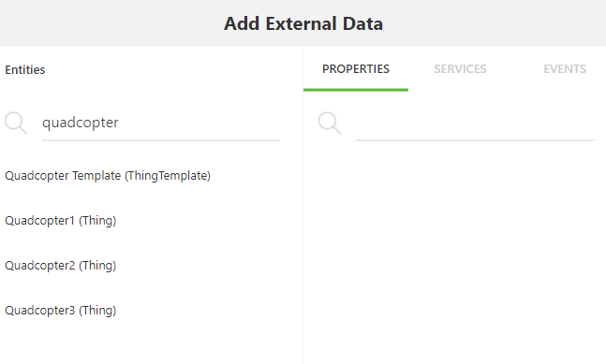

1. Click on any of the numbered Quadcopter Things. Add the batteryCharge property to the experience and click **Close** when finished. You should see the Thing and batteryCharge property appear under **External Data** now.

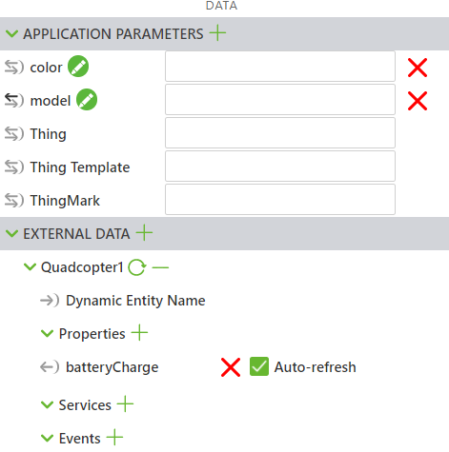

1. You will be using the **Thing** application parameter to call each of the Quadcopter configurations from the IRS. This application parameter needs to be bound to the **Dynamic Entity Name** field of the Thing that you just added to **External Data**. This binding allows for the name of the Thing to become dynamic so that it does not have to be manually changed inside Studio for different configurations.

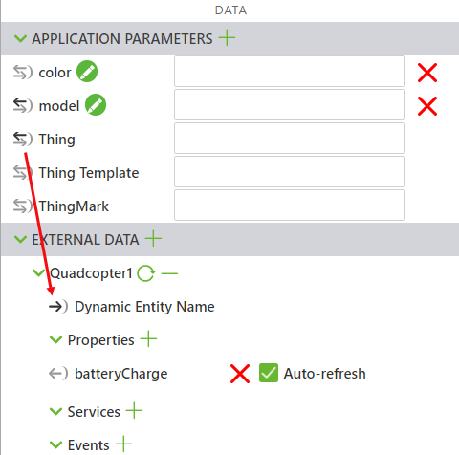

1. Next, bind the **batteryCharge** property from your thing to the **Text** property of the 3D Gauge widget that you added. This will display the battery level in the gauge.

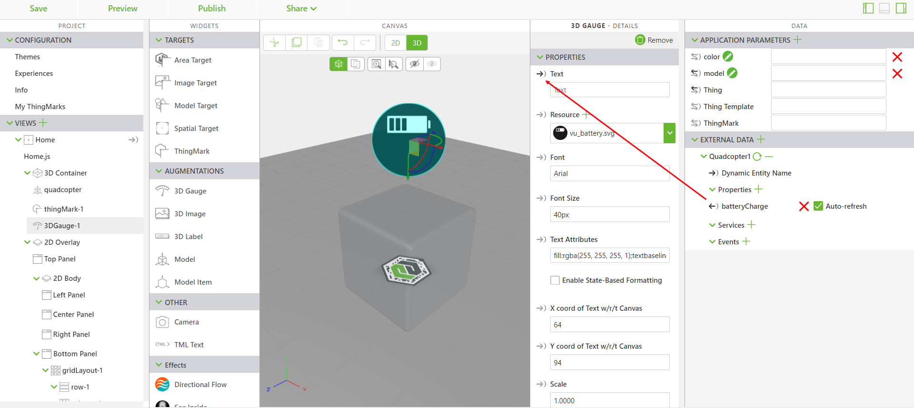

1. This completes all the necessary bindings inside Vuforia Studio. Though the Thing application parameter will be set inside the IRS, you can confirm that the bindings have been created correctly manually. Populate the color and model application parameters with your choice of model and color. Type Quadcopter2 into the Thing application parameter. Click **Preview** to open a preview of the experience. You should see the value that you put for batteryCharge in the gauge. Try again with the other Quadcopter Things and see how the values change, showing the **Dynamic Entity Name** in effect.

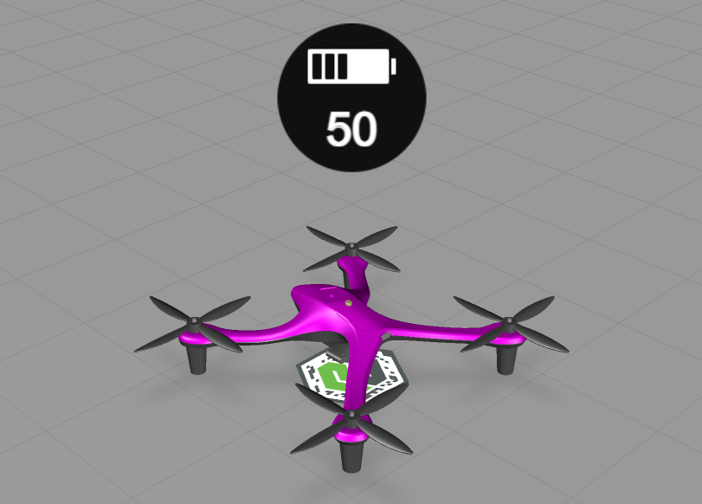

1. Delete all values that you added for each of the application parameters, as these will be filled in by the IRS.
2. Click **Publish** to publish your updated experience.
3. A Vuforia Studio project named [ScalingDigitalTwinExperiences301](https://github.com/PTCInc/StudioExamples/tree/master/Scaling%20Digital%20Twin%20Experiences/Scaling%20Digital%20Twin%20Experiences%20300/ScalingDigitalTwinExperiences301) to be used as a reference with all the additions that have been made in this experience can be found in GitHub. **Note**: this project is for reference purposes, your IRS mappings are still attached to ScalingDigitalTwinExperiences202 unless otherwise changed.

**301.3** **Editing IRS Mappings**

The final step to take for this new set of configurations is to edit the IRS mappings that you created in the previous tutorial. The old template mapping needs to be replaced with one that includes a Thing parameter, which requires deleting and recreating mappings.

1. The first step is to delete your mapping that you made between your template (“key” : urn:thingworx:template:curriculum) and your experience (“value” : projects/…). This mapping needs to be replaced because the Thing parameter needs to be added to the URL just like model and color were. Use the code below to delete the mapping. Where it says IDNUMBER, replace that with the id property of the mapping that you want to delete.

curl -u %uname%:%passwd% -k -H "X-Requested-With: XMLHttpRequest" -X DELETE %server%/ExperienceService/id-resolution/mappings/IDNUMBER

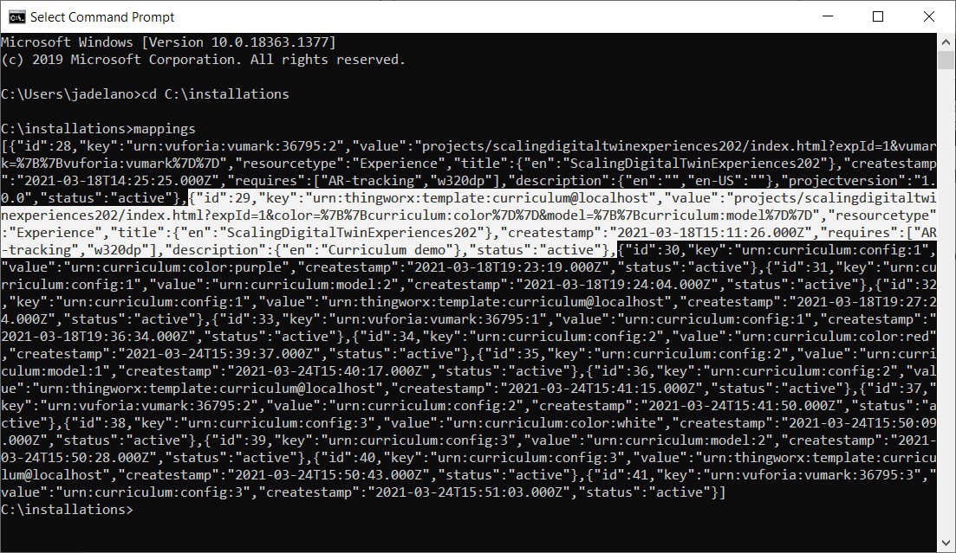

1. Like you did before, run mappings > mymap.bat to overwrite the old batch file of the same name with the new mappings results.
2. Open mymap.bat from its saved location. You will see that it now has entries for all three configurations that you created in the previous tutorial. Repeat the steps that you took for editing it the first time.
   1. Remove the id, createstamp, and projectversion properties from the file completely. Remove the entire value for the key property and remove everything after projects/myproject/index.html?expId=1 in the value property. (**Note:** The formatting of the JSON in the .bat file has been edited for easier readability.)
   2. Like before, you’ll need to add parameters to the URL in the value property. This time, an additional parameter for the Thing application parameter will be added with the color and model of the quadcopter. This will tie the Thing to the configuration.

"value":"projects/scalingdigitaltwinexperiences202/index.html?expId=1color=%7B%7Bcurriculum:color%7D%7D&model=%7B%7Bcurriculum:model%7D%7D&thing=%7B%7Bcurriculum:thing%7D%7D",

* 1. Recreate the key for the experience to map to, which will once again be the curriculum template.

"key":"urn:thingworx:template:curriculum"

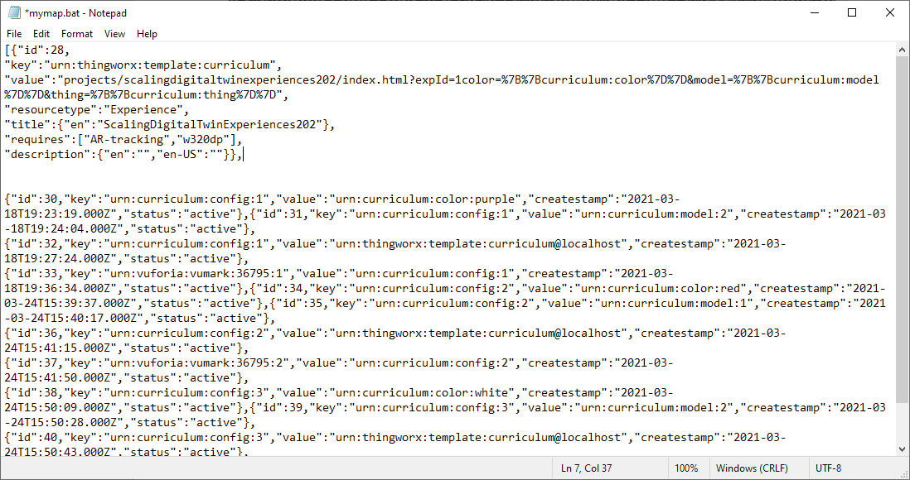

* 1. Save mymap.bat.

1. Use the line of code below to map the template to the updated experience.

curl -u %uname%:%passwd% -k -H "Content-Type: application/json" -H "X-Requested-With: XMLHttpRequest" -k -d "{ \"key\":\"urn:thingworx:template:curriculum\", \"value\":\"projects/scalingdigitaltwinexperiences202/index.html?expId=1^&color=^%7B^%7Bcurriculum:color^%7D^%7D^&model=^%7B^%7Bcurriculum:model^%7D^%7D^&thing=^%7B^%7Bcurriculum:thing^%7D^%7D\", \"resourcetype\":\"Experience\",\"title\" : { \"en\":\"ScalingDigitalTwinExperiences202\" }, \"requires\" : [ \"AR-tracking\",\"w320dp\" ], \"description\":{ \"en\":\"Curriculum demo\" } }" %server%/ExperienceService/id-resolution/mappings

1. Now that your template has been updated, the last step to making the Thing parameter configurable is to map it to a configuration. You will recall that you created three configurations for the model in the previous tutorial. Each configuration can have a different Thing mapped to it. Use the lines of code below to map Things to a configuration.

curl -u %uname%:%passwd% -H "Content-Type: application/json" -H "X-Requested-With: XMLHttpRequest" -k -d "{\"key\": \"urn:curriculum:config:1\", \"value\": \"urn:curriculum:thing:Quadcopter1\"}" %server%/ExperienceService/id-resolution/mappings

curl -u %uname%:%passwd% -H "Content-Type: application/json" -H "X-Requested-With: XMLHttpRequest" -k -d "{\"key\": \"urn:curriculum:config:2\", \"value\": \"urn:curriculum:thing:Quadcopter2\"}" %server%/ExperienceService/id-resolution/mappings

curl -u %uname%:%passwd% -H "Content-Type: application/json" -H "X-Requested-With: XMLHttpRequest" -k -d "{\"key\": \"urn:curriculum:config:3\", \"value\": \"urn:curriculum:thing:Quadcopter3\"}" %server%/ExperienceService/id-resolution/mappings

1. With your new configurations and updated template, scan the ThingMark(s) associated with each of your newly created configurations in Vuforia View. You should now see the different battery levels displayed in the gauge above each configuration.

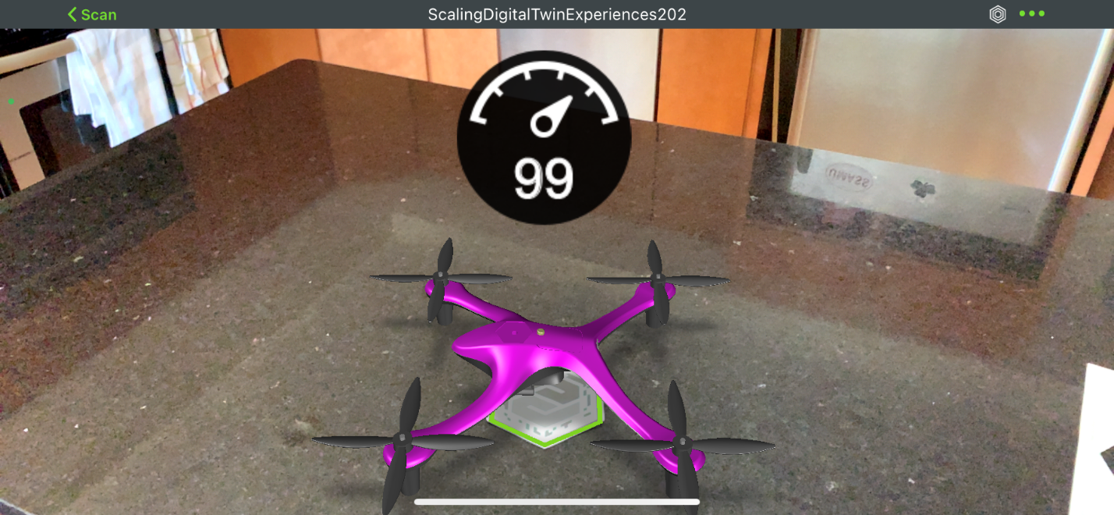

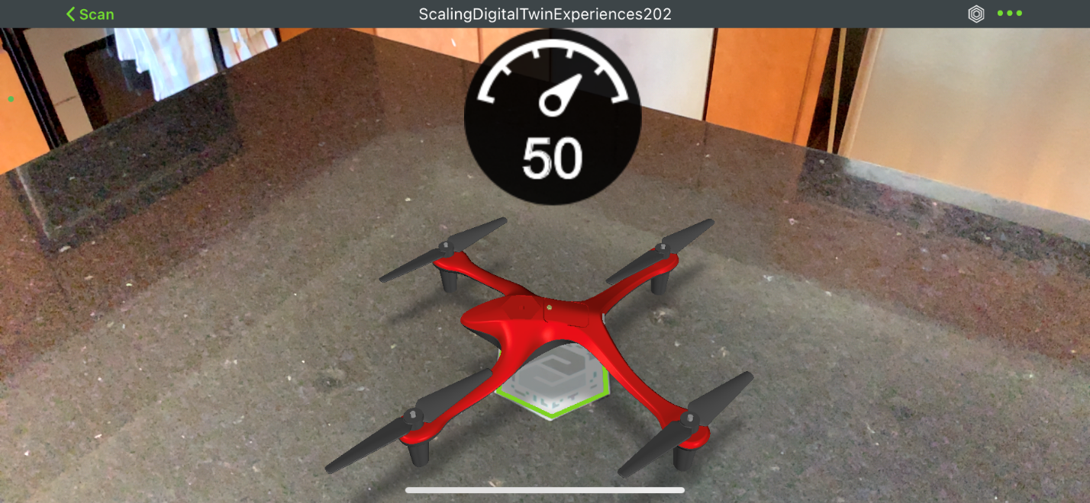

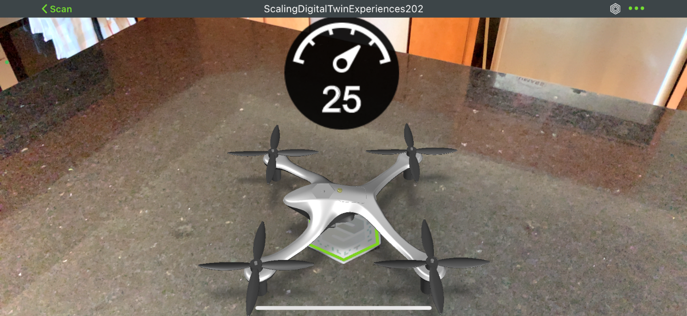

1. If everything works correctly, you have completed this tutorial for adding information to a Vuforia Studio experience using a combination of the IRS and ThingWorx. The mappings file for steps 4 and 5 named [ScalingDigitalTwinExperiences301.bat](https://github.com/PTCInc/StudioExamples/blob/master/Scaling%20Digital%20Twin%20Experiences/Scaling%20Digital%20Twin%20Experiences%20300/ScalingDigitalTwinExperiences301.bat) can be found in GitHub.